SIMATS ENGINEERING (SAVEETHA SCHOOL OF ENGINEERING)
Department of Computer Science and Engineering

CO3 ASSESSMENT TOOL 1 – Git & Docker Technical Assignment

Course Code: | CSA10 / CSA1007 | Course Title: | Software Engineering
CO Assessed: | CO3 | Assessment: | Assessment Tool 1 – Git & Docker  Technical Assignment
Weightage: | 20% | Total Marks: | 25
CO3 Statement: | Build full-stack applications with an emphasis on containerization, version control, and collaborative development
Student Name: | A.SANTHOSH | Reg. No.: | 192311282
Date: | 11.08.2026 | Duration: | 60 minutes

Code of Conduct
I A.SANTHOSH (192311282) certify that this submission is my original work and that I have adhered to the guidelines specified for this assessment. I understand that any violation of academic integrity rules will result in disciplinary action. Signature of the Student: A.SANTHOSH

Problem Statement 1: Smart Traffic Congestion Management Platform

1. Abstract
The Smart Traffic Congestion Management Platform is a web-based software system designed to help municipal traffic authorities monitor road congestion, optimize signal timing, and prioritize emergency vehicles in real time. The platform provides a centralized dashboard for recording live intersection data, vehicle density, average speed, congestion status, and alerts, helping traffic control staff make informed operational decisions instead of relying on static signal timings and manual monitoring. Git and GitHub are used for version control, collaborative development, feature branching, meaningful commits, merging, and remote repository synchronization. Docker is used to package the web application and its dependencies into a consistent runtime environment, and Docker Compose is used to define the application and database services for repeatable local deployment.

2. Problem Statement
Rapid urbanization has significantly increased the number of vehicles on city roads, leading to frequent traffic congestion and longer travel times. Traditional traffic control systems rely on static signal timings and manual monitoring, making them inefficient during peak hours or unexpected incidents. Emergency vehicles often experience delays due to congested intersections, affecting critical response times, and municipal authorities lack accurate real-time traffic analytics for planning infrastructure improvements. The proposed Smart Traffic Congestion Management Platform provides a centralized digital platform for live traffic monitoring, congestion prediction, signal optimization, emergency vehicle prioritization, and commuter notification.

3. Objectives
- Develop a clear web dashboard for monitoring live traffic conditions across intersections.
- Maintain structured intersection records including zone, vehicle count, average speed, and congestion status.
- Provide congestion indicators and alerts for high-traffic intersections.
- Prioritize emergency vehicle routing through congested intersections.
- Demonstrate Git branching, meaningful commits, merging, and GitHub synchronization.
- Containerize the application using Docker for consistent execution.
- Use Docker Compose for repeatable local deployment of the app and database services.
- Test the application through a browser and verify container execution.
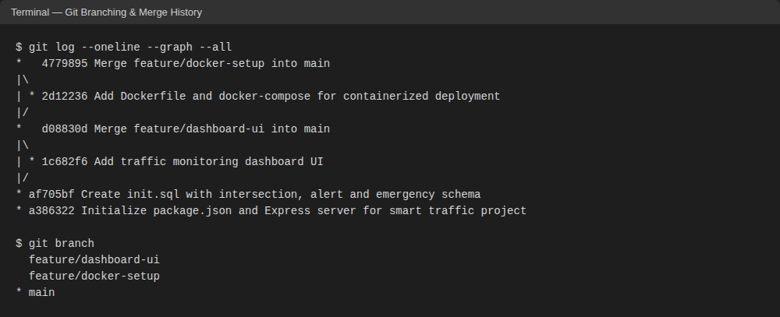
Fig 1: Git Branching and Merge History (feature/dashboard-ui, feature/docker-setup merged into main)
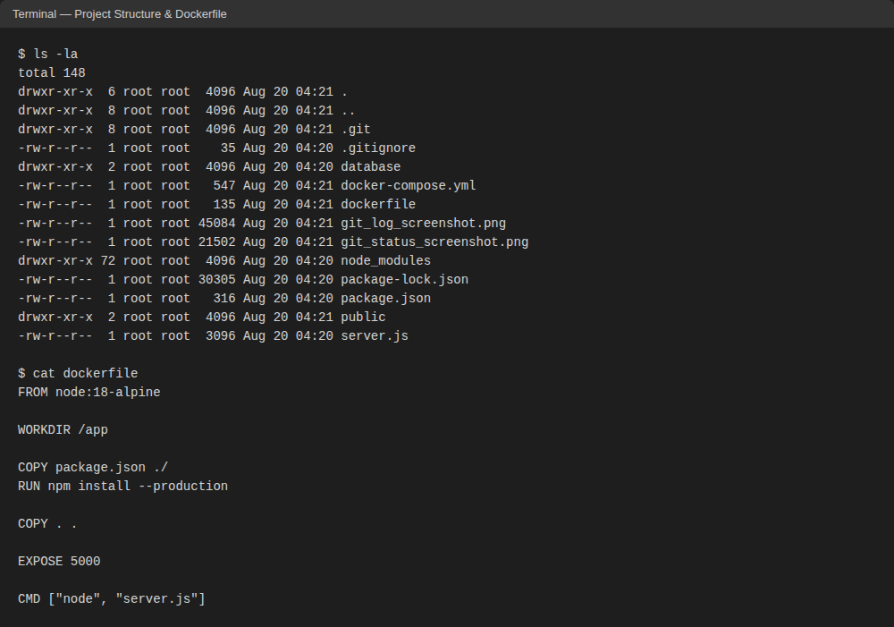
Fig 2: Project Structure and Dockerfile Configuration
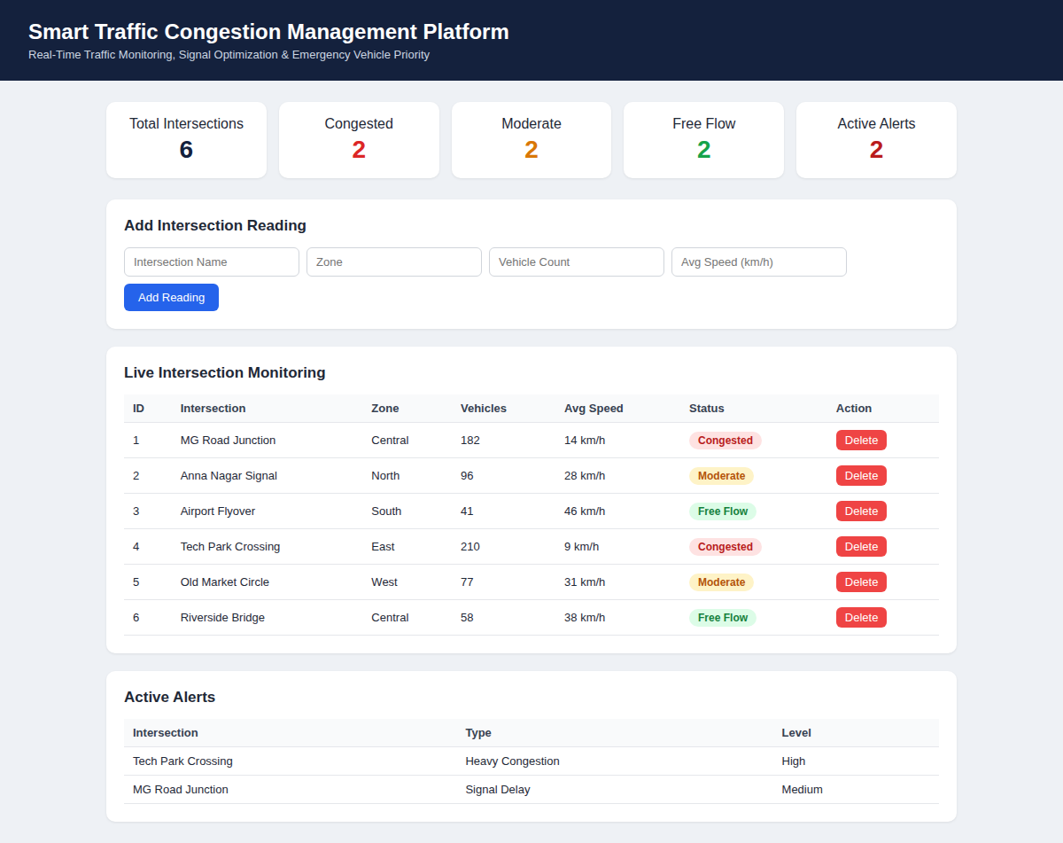
Fig 3: Smart Traffic Congestion Management Dashboard (Live)

4. Technologies Used
Technology / Tool | Purpose | Details
Node.js / Express | Backend programming and application logic | 18.x
HTML / CSS | Frontend interface and dashboard presentation | Web standards
JavaScript | Client-side interaction and dashboard enhancements | Browser-based
Git | Version control and local source management | 2.43
GitHub | Remote repository and collaboration | Remote Git hosting
Docker | Application containerization | Docker Desktop
Docker Compose | Multi-service local deployment (app + MySQL) | Compose v3.9
MySQL | Persistent data layer for intersections and alerts | 8.0
VS Code | Development and terminal environment | Desktop IDE

5. Application Workflow
1. The project is developed and maintained using VS Code.
2. Git tracks application source code, configuration, and documentation across feature branches.
3. The Express backend receives browser requests and serves the traffic monitoring dashboard.
4. Intersection records are loaded from the MySQL data layer defined in database/init.sql.
5. Congestion classification rules (vehicle count and average speed thresholds) identify high-risk intersections.
6. The dashboard displays intersection status, live readings, and active congestion alerts.
7. Docker builds an image containing the application and dependencies.
8. Docker Compose starts the app and database services and maps the application port.
9. The user opens the local application in a web browser and verifies the dashboard.

6. Container Deployment Commands
- docker build -t smart-traffic .
- docker run -p 5000:5000 smart-traffic
- docker compose up --build
- docker ps
- docker logs smart-traffic-app
- docker compose down

7. Deployment Workflow
1. Build the Docker image from the project directory.
2. Start the services using Docker Compose (app + MySQL).
3. Check the running containers using docker ps.
4. Open the application using the browser at http://localhost:5000/.
5. Verify dashboard pages, intersection records, congestion status, and alerts.
6. Inspect container logs if any application or startup issue occurs.
7. Stop the deployment using docker compose down after testing.

8. Conclusion
The Smart Traffic Congestion Management Platform demonstrates the complete lifecycle of a small software project: problem analysis, system design, application development, version control, feature branching, merging, containerization, deployment, and testing. The platform provides a centralized approach to live intersection monitoring, congestion classification, and alerting. Git and GitHub support organized development and traceable project history, while Docker and Docker Compose provide a consistent and repeatable deployment environment. The proposed architecture also provides a strong foundation for future enhancements such as live sensor and CCTV integration, GPS-based predictive congestion modelling, adaptive signal timing, and cloud deployment.

